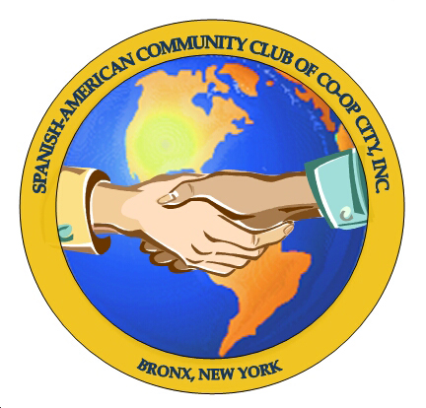
Spanish-American Community Club of Co-op City, Inc.
177 Dreiser Loop Room 16 / P.O. Box 73 Co-op City Station
Bronx, New York 10475
Phone: (718) 379-7017 E-mail: SpanAmCCCC@gmail.com Web: http://spanamcccc.synthasite.com

Jose Lopez MEMBERSHIP APPLICATION Membership Committee
President Luz Peña

Alfonso Gonzalez
Chairperson Date of Application: _______________________ Cash Check _________

Idalia Reyes
Vice-President Last Name: ____________________________________________________

Octavio Cruz
Treasurer First Name: ______________________________ Spouse: _______________________________

Children’s Names: ___________________ ___________________ ____________________ ____________________
(Living in the same household only)

Address: ______________________________________________________________________ Apt.#: ___________

City: _____________________________ State: ___________________ Zip: _______________

Telephone: ( ) _______-__________ Email Address: _______________________________________________
Check here to you prefer to receive club correspondence by email only.

Please mark any committees that you would like to take part in:

Social: ______ Cultural: ______ Youth: ______ Membership & Public Relations: ______

Visitation: ______ Scholarship: ______ Sunshine: ______ By-Laws & Constitution: ______

Please list any special talents or hobbies you have that you would like to share:

___________________________________________________________________________________________

___________________________________________________________________________________________

Please note: General Membership Meetings are held on the 2nd Thursday of each month between September and June.
Dues are $35 annually, per household, required by the end of January. After January, you will be charged
$4 monthly until the next year begins.

FAMILY MEMBERSHIP CONSISTS OF FAMILIES LIVING IN THE SAME HOUSEHOLD ONLY

OUR ORGANIZATION DOES NOT ENDORSE CANDIDATES RUNNING FOR OFFICE OUTSIDE OF THE CLUB

